Harmful Algal Bloom (HAB) and Cyanobacteria Update
June 15, 2023

The Logan County Health District receives reports of satellite imagery from the Ohio Department of Health for Indian Lake. Satellite imagery and the data it produces is still considered experimental and is being made available for community awareness. This satellite imagery can indicate the presence of cyanobacteria, which are microorganisms that can produce harmful algal blooms (HABs). HABs have the potential to make animals, including humans, sick and can also harm the aquatic environment.

The latest satellite imagery for Indian Lake, taken June 10, 2023, is showing some cyanobacteria coverage, estimated to impact 10-50% of the lake. Please see the image below for the current imagery as of June 10, 2023.

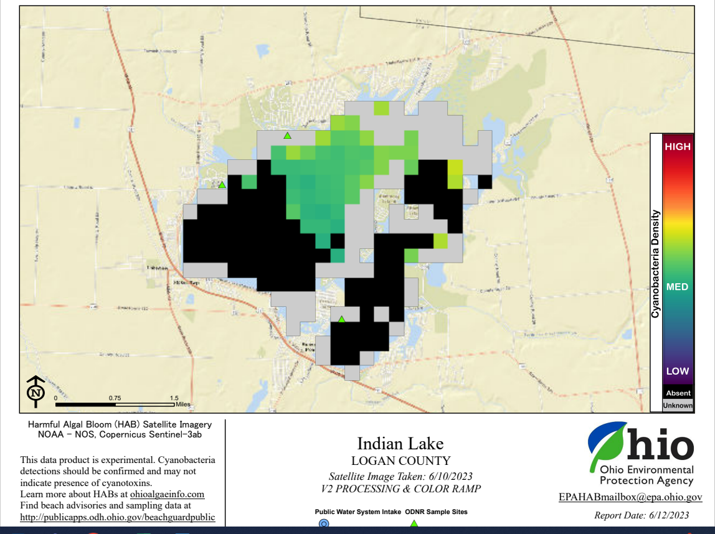

Satellite imagery also showed possible HABs in the summers of 2021 and 2022, but no animal or human illnesses were reported to the Logan County Health District.

The most common ways to come into contact with HABs are through drinking/swallowing, skin contact and inhaling. Drinking/Swallowing HABs-contaminated water can cause severe diarrhea and vomiting, liver toxicity (abnormal liver function, abdominal pain), kidney toxicity, neurotoxicity (weakness, salivation, tingly fingers, numbness, dizziness), difficulty breathing, and death. Skin contact with HABs-contaminated water can cause rashes, hives, and skin blisters (especially on the lips and under swimsuits). Inhaling HABs-contaminated water can cause runny eyes and nose, sore throat, asthma-like symptoms, and allergic reactions. For more information on HABs please visit https://odh.ohio.gov/know-our-programs/harmful-algal-blooms/welcome-to-habs.

If you come into contact with HABs-contaminated water, rinse off with clean, fresh water as soon as possible. Individuals who are concerned that they may be experiencing HABs illness symptoms after exposure to contaminated water should contact their healthcare provider. Healthcare providers who rule out other potential causes of the symptoms and suspect a HABs illness should notify their local health district.

Pets can also experience serious health effects from exposure to HABs-contaminated water. Contact a veterinarian immediately if pets show signs of illness. Thoroughly rinse off your pets with clean, fresh water. Pets that have been in HABs-contaminated water may ingest toxins by drinking the water and/or licking their fur afterward. Do not let your pet lick himself/herself if he/she has been in HABs-contaminated water or swimming in a body of water with a posted advisory.

Seek immediate medical attention if you think that you, your pet, or your livestock might have been poisoned by HAB toxins or if someone has a medical emergency.

HAB illnesses are considered to be reportable. To report a HAB illness, or if you have any questions or concerns, contact the Logan County Health District at (937) 592-9040 or LCHD@loganhealthohio.gov.

