Sizing a Grease Interceptor Worksheet
New or Replacement
Site Location: _____________________________________________________________________________
1. Measure your sinks. Calculate the capacity of the sink in cubic inches by multiplying length by width by depth. If you have multiple compartments or sinks, add the capacity of sinks together to find total cubic inches:
_____ x _____ x _____ = _______ Cubic Inches x _______Number Sink Bowls = Total Cubic Inches_______
Length x Width x Depth
2. Convert the capacity from total cubic inches to gallons per minute (GPM) by dividing by 231:
_______ Total Cubic Inches ÷ 231 = _______ GPM
3.) Adjust for displacement (displacement takes into consideration the actual usable capacity of your sink):
_______ GPM x 0.75 = _______ GPM Actual Drainage Load for sinks
4). Add any additional appliances (optional) SKIP IF ONLY ONE FIXTURE
Note: Dishwashers can be connected to a Grease Trap only if allowed by local code. Each dishwasher will require a separate Grease Trap. For floor drains and floor sinks take the volume of water produced by the number of hose bibs (i.e., 1.5 - 2.0 GPM per 3/4-inch faucet).
____________ + ___________
Actual Drainage Load for sinks + Other Appliances and sinks
5.) Determine the flow rate and drainage period. Drainage period is the actual time it takes to completely drain the fixture.
_______ GPM ÷ 2 min drainage period = _________ GPM Total Actual Drainage Load
GPM Total _________
Capacity lbs. _________ (check chart)
Manufacture: _____________________________
Model: __________________________________

Additional Information and PDI booklet (instruction, installation, maintenance) can be found at www.pdionline.org/about-pdi
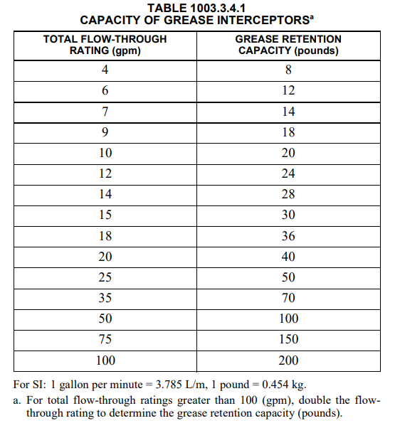
Table From 2017 OPC/2015 IP
Draw a diagram of sink and grease interceptor location on back of this paper

